Creative curriculum homework – Roman Britain: What did the Romans do for us?
Choose 4 tasks from the table below and bring your homework in ready to present to the rest of the class during the week beginning:
- Monday 28th September
- Monday 19th October
- Monday 16th November
- Monday 7th December
As you are aware, we are working hard to improve our oracy skills. Presenting your work to the class is an ideal opportunity for you to showcase your skills, so please practice presenting your work at home to your family.
Include an introduction about your work. What did you enjoy learning/doing? Speak clearly. Be prepared to answer questions.

Invent a game  Find out which games Roman children would have played. Can you design and make your own game for others to play at school? Can you include Roman numerals?  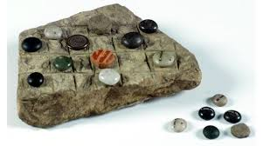 | Be a reporter  We are going to be learning about the eruption of Mount Vesuvius.  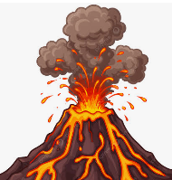  Research volcanoes and record yourself, in role as a volcano expert, giving facts about volcanoes around the world. | Be an archaeologist  Research Roman artefacts that have been found by archaeologists and make a Power point to present to the class.  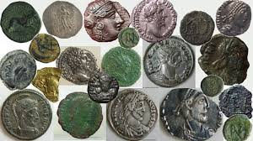 | Tour guide  Find out about modern day Rome as a tourist destination by using holiday brochures or websites. Which tourist attractions would you visit? What is the climate like? Where else would you go in Italy? Design a trip to Rome and include activities for people to do.  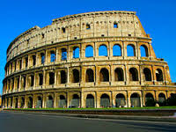  You could make a  brochure or record  your own Podcast.
Roman Maths  Write some number calculations using Roman numerals for your friends and family to solve. Or use a paper plate to create a clock with Roman numerals to help you practise telling the time.  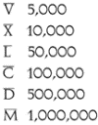 | The Roman Army  Investigate what a Roman soldier would have worn and needed. Make a model or a drawing of a Roman soldier, using labels to explain clothing and equipment.  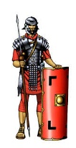 | Mountain Air  We are going to be learning about mountains, how they are formed, names of mountains and their locations.  Make up a poem about climbing a mountain – what can you see; how do you feel as you climb; how do you feel when you reach the top?  It can be any type of poem; e.g. a shape poem; an acrostic; a haiku. | Make a meal of it  Research Roman food and design a Roman menu for the day. You may like to have a go at cooking at home and bring/email in photos. Compare with modern Italian food. What is your favourite Italian dish?  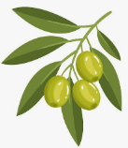

Juniper Homework

- Reading – please read as often as you can to an adult and discuss the book you have read. Make sure the adult records it in your reading record book so you can be entered into our reading raffle which will be drawn on a Monday. You are expected to read at least 5 times a week, either to yourself or to an adult.
- Spellings – practice your spellings ready for your test on Thursday. Each Thursday you will be given your new set of spellings to learn.

- Times tables – These will be practised every day in school. Please learn the times tables for that week. Use TTrockstars to test yourself at home at least 10 minutes, 4 times a week. Login and password can be found at the front of your reading record book. Can you complete 3 games on Studio to reach your rock status? How fast and accurate are you on Sound Check? Year 4 have their government times tables test in June where they will need to answer 25 questions (6 seconds for each question). The test is set up very similar to Sound Check on TTR using the number pad at the side on the keyboard.

- Maths – Complete maths sheet to practise the 4 written methods of addition, subtraction, multiplication and division and to reinforce concepts that we have been learning in class. This should be handed in on Wednesdays and will be marked in class during the maths lesson.

- Please complete 4 pieces of creative homework over the term. Be prepared to present your homework during the weeks beginning on the following dates:
- W/b Monday 28th September
- W/b Monday 19th October
- W/b Monday 16th November
- W/b Monday 7th December

http://www.bbc.co.uk/bitesize/ks2/english/
http://www.everyschool.co.uk/history-key-stage-2-romans.html
http://www.bbc.co.uk/schools/primaryhistory/romans/
http://www.ngkids.co.uk/did-you-know/10-facts-about-the-ancient-Romans
http://www.roman-numerals.org/chart100.html
https://hands-oneducation.com/blog/2024/chalk-games-inspired-by-the-romans.html#gsc.tab=0
https://www.natgeokids.com/uk/discover/geography/physical-geography/volcano-facts/

