Willow Class Summer Term Creative Curriculum homework - Paddington
Draw and label what Paddington keeps in his suitcase.  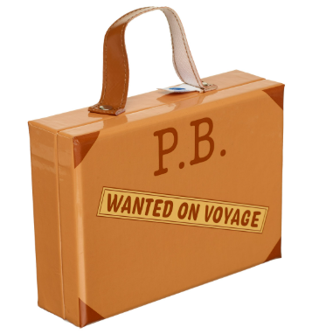 | Draw and label and write a character description of Paddington Bear.   | Draw a map and label a map showing Paddington’s journey from Peru to London showing compass points.   | Research Peru or Lima and create a powerpoint or fact sheet.  
Create a collage of famous London landmarks (printed or drawn).   | Draw, write about or build famous London landmark.   | Find out about the author, Michael Bond.   | Create a Paddington Comic Strip: Draw a 4-6 panel comic strip showing a funny Paddington Adventure.  
Please hand in your creative curriculum homework on the following dates:
- Wednesday 29th April 2026
- Wednesday 20th May 2026
- Wednesday 10th June 2026
- Wednesday 8th July 2026
On these dates the children will be presenting their homework to the other children in the class to practise their oracy skills.
TTRockstars times tables: practise your times tables at least 20 minutes per week on TTR. Use ‘Jamming’ to practise times tables with no timing. Use ‘garage’ to practice the times tables that we are practising in class. Can you complete 3 games on Studio (all times tables) to reach your rock status?
Spellings Friday: Spelling tests and new spellings given. (Children will also be practising the spellings every day in class).
Reading Monday: hand in reading record book to Mrs Wildman on Monday morning. Have you read 4 times or more to get yourself into the reading raffle and win a prize?
Please ensure that you are reading and discussing books with your child at least 4 times a week. Children are able to complete an AR quiz when they have finished reading their book to show their understanding of their book.

