Willow Class Spring Term Creative Curriculum Homework – The Ancient Egyptians
Research the Egyptian number system. Write some word problems using it.  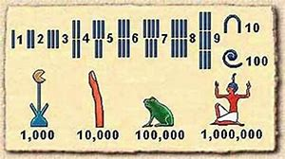  Don’t forget to work out the answers too! | Design or make an Ancient Egyptian Sarcophagus.  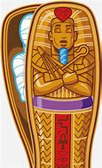 | Research Ancient Egyptian facts and write your own quiz.  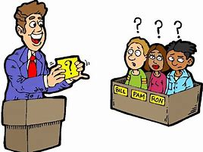 | Find out about Egyptian gods. Can you make a set of top trumps for the gods of Ancient Egypt? http://primaryhomeworkhelp.co.uk/egypt/gods.htm  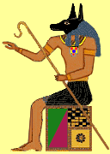
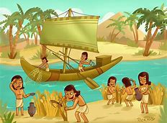  What was the importance of the river Nile in Ancient Egyptian times? Research and create a factsheet or Slideshow. http://resources.woodlands-junior.kent.sch.uk/homework/egypt/nile.htm | Find out about the mummification process. Then mummify a tomato or apple!  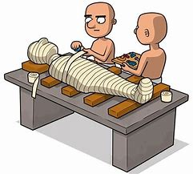 | Create a word search or crossword about Ancient Egypt.  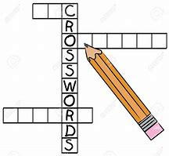 | Find out about Egyptian hieroglyphs. Write your own message in  hieroglyphs.  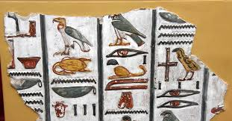
Build your own pyramid. Perhaps use a 3D net in card.  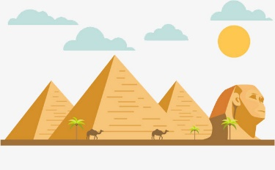  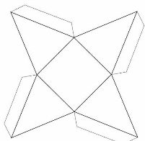 | Draw a map of a Pharaoh’s tomb. Write a set of instructions to get through, avoiding any traps. Use directional language.  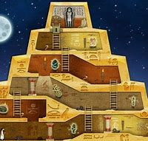 | Go on www.discoveryeducation.co.uk/espresso  Research Ancient Egyptians and look at quizzes and videos  Username: student24721  Password: reeves | 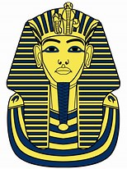  Create a fact file or comic strip on Howard Carter and find out how he found the tomb of Tutankhamun
Homework:

Please hand in your creative curriculum homework on the following dates:
- Thursday 29th^{t} January 2026
- Thursday 12th February 2026 and Ancient Egyptian Day (separate letter will be sent out)
- Wednesday 4th March 2026
- Thursday 26th March 2026
- Over the term: children are to choose a homework task from the homework grid and complete to the best of their ability. Then be ready to show their homework in class practising their oracy skills.
TTRockstars times tables: practise your times tables at least 20 minutes per week on TTR. Can you complete 3 games on Studio to reach your rock status?
Spellings Friday: Spelling tests and new spellings given.
Reading Monday: hand in reading record book to Mrs Wildman on Monday morning. Have you read 4 times or more to get yourself into the reading raffle and win a prize?
Please ensure that you are reading and discussing books with your child at least 4 times a week. Children are able to complete a quiz when they have finished reading their book to show their understanding of their book.
Useful websites
http://nrich.maths.org/students
https://www.topmarks.co.uk/maths-games/hit-the-button
http://www.bbc.co.uk/bitesize/ks2/english/

